**Community Hedge Fund**

**Do you know the rich benefits of having hedgerows in the landscape, both rural and urban?**

Are you aware of just how much hedgerow we have lost in the last 70 years?

Are you involved with a community group who are inspired to run a project to reverse hedgerow loss? Join CPRE’s effort to acheive our target of increasing the length of hedgerows in the UK by 40% by 2050! **#40by50**

The patchwork blanket of **hedgerows is a symbol** of the British countryside, reflecting centuries of ancient rural farming practices. Hedgerows are **crucially important for the wildlife** that has learnt to live amongst human settlements and within the farming landscape. They provide a network of food and shelter and are a means of navigation for so many animals; from insects, including pollinators, and birds to small mammals. Over 2,070 species were found in a single stretch of hedgerow in Devon. Hedges can provide the niches required for a diverse range of animals, including threatened and endangered species such as the hedgehog, hazel dormouse, turtle dove, great crested newt and many bats.

Hedgerows can also be beneficial in an urban environment, providing much-valued greenery in a streetscape and offering food and shelter to birds and insects.

Since World War II about half of England’s hedgerows have been lost. Many were ripped out to improve agricultural efficiency, others were simply abandoned. Many hedges today are being managed using harsh and damaging trimming regimes which will eventually lead to the loss of those hedges that are still clinging on. Where wildlife once thrived, it is now **a common sight to see hedges with holes in**, bare at the base or entirely separated into hedge islands, providing no functional use at all.

Beyond the benefits of hedgerows for wildlife, we must not overlook the potential for **carbon capture**. As plants grow, they convert the carbon in the air into the sugars they use to grow. This makes plants one of our great allies as we face the momentous challenge to reduce and revert our carbon footprint. Hedges in poor condition are slowly dying, far from growing at rates close to their full potential each year. This means that they are not removing the annual quantity of carbon from the air that they could be.

*To read more about this please check out our recent article available online:* [*Hedgerows and the Fight Against Climate Change - CPRE Hampshire*](https://www.cprehampshire.org.uk/what-we-care-about/hedgerows/cpre-hampshires-hedgerow-heroes-initiative-2021-22/hedgerows-and-the-fight-against-climate-change/)

**Application for Community Hedgerow Planting Project**

At CPRE Hampshire, we are delighted to support community hedge planting projects by providing whips, guards, and canes to help local communities increase their hedgerow cover. Hedges supported by our Community Hedge Fund must be accessible to the public.

We can also provide advice and guidance on getting started, how to plant a hedge, how to care for and manage your new hedge, as well as resources to promote awareness and education around the benefits of hedges for wildlife, farming, and climate. We have ready-made Key Stage 1 and 2 materials for schools. Where appropriate, we can also provide support and hands-on advice with hedge planting.

**Please kindly note**, our Community Hedge Fund supports hedge planting projects by providing whips and the materials and is **not a cash grant.**

Planting can be done by the community group or by other means, e.g. scout groups, schools, community members. We strongly encourage groups to recruit local community members to help with the planting, however, you can request for it to be done by the CPRE Hampshire volunteer team.

**The planting must be done:**

1. With 1-2yr whips (using additional mature saplings must be provided by other means).
2. Between November and March, but November and December are best.
3. Using native species, for example, hawthorn, blackthorn, privet, spindle, crab apple, dogwood, guelder rose, field maple, wayfaring, hazel, dog rose.
4. Forming a mixed hedge of 7+ species to maximise the benefits to wildlife.

We recommend planting in a zig-zag, with spacings approximately 30-40cm apart.

**Species spacing advice from Ellie Banks, Hedgerow Project Officer**

Planting too many of the same species together can cause gaps when livestock preferentially eat it – see photo showing the effects of spindle being preferentially browsed by cattle.

However, alternating every whip to a different species creates quite an unnatural hedge. The guidance I like to give is to have thorn one side of the zig zag (whichever side you want to keep things out – whether that’s keeping animals or people away from the field!). The hawthorn also takes particularly well so gives you a good chance of having a continuous hedge sooner.

Read this advice from the Tree Council on protecting your young hedge plants: [7.-PROTECTING-YOUNG-TREES-best-choice-for-your-planting-project-Setember-2021_v8.pdf (treecouncil.org.uk)](https://treecouncil.org.uk/wp-content/uploads/2021/11/7.-PROTECTING-YOUNG-TREES-best-choice-for-your-planting-project-Setember-2021_v8.pdf)

We request that the CPRE Hampshire logo be displayed in the location as credit to the funding provided, helping to promote our efforts to spread the word about the importance of hedges.

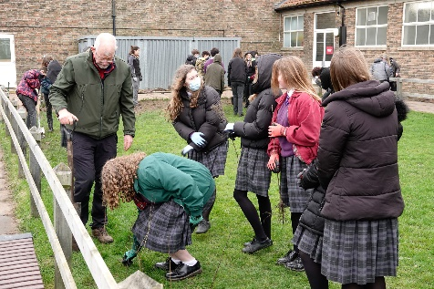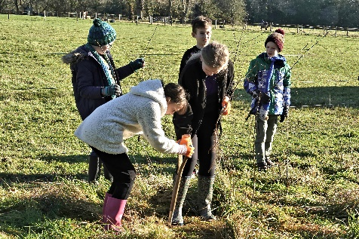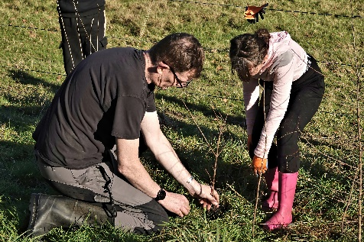

|  |  |  |  |  |
| --- | --- | --- | --- | --- |
| **Name of organisation (e.g. school, parish council, sports club):** | | | | |
| **Contact name:** | | | **Tel. No:** | |
| **Email: Website:**  **)** | | | | |
| **1. Tell us about your hedgerow planting plans in your local community.**  **What length of hedgerow would you like to plant?**  **Where will the hedgerow be? (We require that the hedge is planted somewhere accessible to the public such as a local park, village green, sports ground, school grounds, publicly accessible footpath, nature reserve, other communal grounds.)**  **Who will organise and run the project? (Doesn’t need to be one person, but responsibility should be assigned as we find this is the most successful way of making sure a project is seen through to completion.)**  **What experience do you have as a group?**  **How confident do you feel about being able carry out your plans (planning through to implementation and aftercare)?** | | | | |
| **2. Why do you want to run this project? Please describe in measurable terms what difference you are going to make to your local area? What is your target(s) with this hedge planting? (for wildlife, carbon capture, awareness building, amenity value).** | | | | |
| **3. Timetable for project launch**  Start date: End date:  We can only support projects which are completed by the end of March 2026. | | | | |
| **4. Please tell us what resources you will need. We recommend projects use guards and canes where deer pressure/ hares/ small mammals may browse. If unsure, please ask and we can advise.**  **Please write the exact number of whips/ canes/ guards you will need. Whips are planted at a rate of 5 whips/ meter.** | | | | |
| **Resources needed:** | **Whips** | **Canes** | | **Guards** |
| **EXAMPLE for 100m hedge with guards/ canes** | **500** | **500** | | **500** |
| **EXAMPLE of 100m hedge without guards/ canes** | **500** | **NA** | | **NA** |
|  |  |  | |  |
|  |  |  | |  |
|  |  |  | |  |
|  |  |  | |  |
| **5. Please estimate the number of people you hope this project will affect, both direct (e.g. those involved in the project – planning, planting, promoting) and indirectly (those who will be able to see it – next to footpath, public place, plans to invite public to the reveal, inviting school children to learn more about hedges etc…).**  **The more people who see it the better so we can spread awareness about the importance of this project and the benefits of the humble hedgerow!** | | | | |
| **5. Please tell us about your plans for maintaining your hedge once you have planted it (watering, checking and removal of tree guards if used, replacement of unsuccessful whips, future management of the hedge e.g. laying)** | | | | |
| **6. Please include photos of your hedge site. These will be useful for us to start assessing the suitability (and may be great for BEFORE and AFTER photos!)** | | | | |
| **Please tick this box to consent to your photos being used for CPRE Hampshire’s**  **use in promotion and publicity in the future.** | | | | |

Please understand that we have limited resources and only the projects we believe will be most impactful and positive for the local community will be awarded whips/ materials. If your project is not selected, please don’t be disheartened as this means there is a wonderful, active and inspired community in Hampshire who are keen to put their time in for free to try to improve our local environments for the greater good of us all. This is an immeasurable success!

Successful projects will be asked to submit a final monitoring report summarising how the funding has helped their project - along with photographs of the finished project.

We request that any publicity about your project (printed or digital) carries our logo (see guidance sheet).

**Please complete and return the form electronically to Ellie Banks at** [**hampshirehedge@cprehampshire.org.uk**](mailto:hampshirehedge@cprehampshire.org.uk)**.**

Funding available until December 2025. Projects must be carried out during the hedge planting and laying season, between November and March, and therefore all projects must be completed by 31st March 2026.

**To avoid disappointment, we advise submitting a form a.s.a.p.**

**Enquiries or questions?**

**Please email Ellie Banks, Hedgerow Project Manager, CPRE Hampshire**[**hampshirehedge@cprehampshire.org.uk**](mailto:hampshirehedge@cprehampshire.org.uk)