A WATER RESOURCE POLICY FOR CPRE HAMPSHIRE - Sept 21

To protect our rivers and water supplies and prevent flooding in a time of climate uncertainty and rapid development and changing planning control.

A CONTEXT
B ISSUES FOR CPRE HAMPSHIRE
Protecting the Resource
Demand Reduction
Water Quality and River Biodiversity
Flooding
Climate change

C POLICY DEVELOPMENT
Policy 1 Support efficient Use of existing Resource
Policy 2 Support Demand Reduction
Policy 3 Link Planning and water
Policy 4 Support Agricultural Practices to conserve Water in the Catchment
Policy 5 Change Attitudes

D WHAT MEMBERS CAN DO
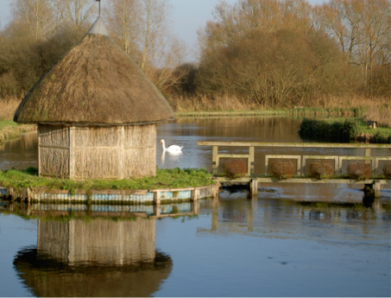
E REFERENCES

The Bunny
R Test
Longstock
MMG

A CONTEXT

Water is an essential resource but rising demand, planned growth and climate change raise difficult issues for sustainable water resource management. It is now being increasingly recognised that efficient use of water, conservation of supplies, reduction in demand, and much better land use planning are all essential for maintenance of water quantity, water quality, river biodiversity and the avoidance of flood risk.

Hampshire is in that part of Southern England defined by the Environment Agency as being one of Water Stress and is particularly susceptible to overuse of its ground water resources through over abstraction. Drought conditions have particularly severe effects on the health of our internationally important chalk river systems and their biodiversity. As a farming county, we need to consider farming practices and their impact on water quality and quantity too. The large number of planned housing developments, and the need to re-enliven the industrial base, have profound implications for sustainable water use.

Hampshire lies in the southern, drier part of the UK. Its geology is characterised first by the Hampshire (chalk) basin, which is a major aquifer and source of base flow for chalk streams and via direct abstraction and river abstraction for the commercial and agricultural water supply. Protection of the aquifer has implications for water quality and river biodiversity and also for groundwater flooding.
Secondly, the south of the county is dominated by Tertiary sands and gravels producing flashy streams more likely to cause flood risk.

Streams in the northern part of the county drain towards the Thames, are on both chalk and Oxford Clay and have flashy and chalk stream characteristics.

The coastline and estuaries along the Solent are a potential source of flooding although the Isle of Wight mitigates Atlantic waves and surges.
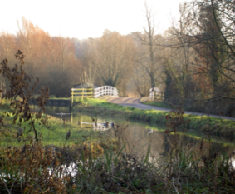

The Bunny
R Test
Longstock
MMG

B ISSUES FOR CPRE HAMPSHIRE

We therefore see the main components as being:
The Resource: protecting the groundwater sources, rivers and springs. Water quality, quantity, biodiversity and flows. Rivers are an essential part of the valued Hampshire landscapes and have economic and social value as well as the biodiversity. All could be compromised by abstraction for increasing demand. Increasing the resource by desalination and water transport need careful consideration on a case by case basis.

The Demand: Demand reduction, via planning and building regulation which takes account of water supply and is enforced at Government level, and metering (which is now being rolled out throughout Southern Water’s region).

Wastewater: safe and appropriate disposal and recycling, grey water use (this will involve changes to building regs and water company involvement).

Flooding: sea flooding, Environment Agency responsibility, and river flooding is the responsibility of the EA. Surface water flooding (eg excessive rainfall leading to ground water rise) HCC and local councils have this responsibility. Development in areas prone to flood should not happen.

Information and communication to raise awareness of these issues and attitudes to them. CPRE Hampshire can help by monitoring Water Companies’ policies and actions through stakeholder roles and informing members and the wider public

These aspects are inter-dependent. They overlap and are all interlinked.

Protecting the Resource, Demand Reduction,
Water Quality and River Biodiversity
To protect our rivers and water supplies and prevent flooding

Increasing demand for housing and the need to revitalise industry in the county leads to increasing demands for water. People in England and Wales use 145 litres of water each per day on average (lpppd) a rise of 70% since 1979. By 2022, use will increase by approx. 5% (800 million gallons per day nationally (DEFRA)). The Government’s target is to lower this to 120 lpppd. (DEFRA).

The drought of 2011-12 has shown that this demand, whether satisfied from groundwater or river sources, can lead to low flows in rivers and in extreme cases to their drying up. (There are enough abstraction licenses in existence to remove flows altogether in many British rivers). This drought is likely to recur. (Graham Warren Protect Kent - Bookham presentation October 2012)).

Drought orders have been applied for every year on the Test under the Section 20 agreements with the EA (2019) but heavy rainfall has so far averted the orders’ execution.

Diffuse pollution from farm sources and the inability of some domestic sewage systems to cope in wet periods have implications for water quality in our rivers cf the Bourne Rivulet a tributary of the Test. The problem of nitrates has exacerbated during 2020-21.

Flooding
The wet year of 2012 has highlighted the problem of flooding. Although Hampshire’s rivers are not mostly flashy they can still flood over their natural flood plains in all sections of their courses and we need to lobby strenuously to preserve the provisions of para 94 of the NPPF, (which relates to planned development in flood plains), is taken full account of. Flooding should not be caused by new developments either ON or OFF site. (HCC Local Flood Risk Management Plan)

Ground water flooding due to a rise in aquifer levels was the cause of the extensive flooding of 2001/2014. Most parishes have a flood watch group (set up after 2001) which keeps an eye on ground water levels and alerts residents to any threat.

Rising sea levels already evident due to thermal expansion of the oceans will reduce rivers’ ability to scour silt from their beds making floods both at the coast and inland, more likely.

Climate Change

The uncertainties of climate change should help us to justify being cautious. Rainfall has been seen to be erratic and intense, often prolonged. Infiltration is reduced by impermeable urban and rural surfaces. Transpiration is reduced and evaporation decreased by unvegetated fields during wet periods.

Drought in the South East has been a recurring problem. The region has been declared one of water stress by the Environment Agency and 25% of the area was under drought orders in 2012.

Water Companies, nonetheless, have a statutory duty to supply water to existing and planned developments. The Environment Agency has recognised the situation and is reducing abstraction amounts and licenses where it can but abstraction in drought conditions leads to the lowering of the water table. Rivers are fed from this, and low flows will lead to reductions in water quality and quantity and this will inevitably degrade biodiversity.

The proposed unbundling of abstraction licenses for onward sale (Govt Water Bill) could lead to even more abstraction licenses being activated.

C POLICY DEVELOPMENT

Given these elements, CPRE HAMPSHIRE will adopt the following policies:

Policy 1 Support efficient use of existing resource
To protect our rivers and water supplies and prevent flooding

First among the principles that CPRE HAMPSHIRE applies to these issues is the need to use existing water supplies more efficiently through water conservation measures, including catchment management at the supply side and water metering on the demand side. Progress in combating leakage must be monitored.

In times of water shortage, we are very concerned that the drought triggers used by the water companies should not be set so low that water supply to rivers and streams is compromised.

Resource
Resist over-abstraction of ground water when it will impinge on river biodiversity.

Contest the provisions in the Government’s Water Bill, which could allow the sale of unused abstraction licenses by those who hold them.

Reservoir schemes to store surface water during pluvial floods should be treated on a case by case basis as they can enhance landscape but can also be very contentious.

Farming techniques, including increased interception of rain by forests and grassland and enhancing humus rich soils and reducing ploughland will be supported. Construction that prioritises permeable surfaces (SUDS) should be encouraged so that the aquifers are constantly recharged.

Increasing water reserves through desalination and water transport should be considered on a case by case basis and not instead of the above.

Policy 2 Support demand reduction in these times of water unpredictability is essential. This involves strong lobbying on both planning controls and building regulations.
To protect our rivers from over abstraction, to maintain water supplies and prevent flooding.

Demand
Increasing demand for housing means an increasing demand for water. People in England and Wales use 145 litres of water per day on average (lpppd) a rise of 70% since 1979. By 2020, use will increase by 5% and other 800 million gallons per day nationally (DEFRA). The Government’s target is to lower this to 125 lpppd (Defra). This demand side measure can best be effected by:
  - supporting the water companies in installing meters;
  - lobbying planners to consider the adequacy of supply to new developments and to respect para 94. NPPF.
  - Lobbying planners to require builders to install Code Level 3
measures which would lower the water use to 105 lpppd in new-builds.

New houses have to comply with government’s Code Level 1 and 2 for water conservation, i.e. 125 lpppd. Code Level 3 (105 lpppd) would be preferable. Encouragement to builders and planners to install at Code Level 3 would reduce lpppd to 105 litres in new builds.

Older houses use far more water than new and continue to make demands on supplies that, when scarce, could lead to an unacceptable lowering of the water table. Lobby membership and planners to enable retrofitting.

More efficient water appliances (a single toilet flush can use 9 litres of water) and grey-water systems, which use recycled water, could have a significant positive effect.

Since 1997, leakage has reduced by 27% (Southern Water Co. SW) and the water companies plan to reduce by a further 10% by 2035.

Demand reduction should be managed by encouraging water companies to install metering as soon as possible. They should also continue to improve leakage control to help conserve existing supplies. (SW current policy)

Waste water systems should be updated as soon as possible and the cleaned recycled water reintroduced to the river systems or reservoirs where it is now discharged to the sea. Support the retrofitting introduction of low flush toilets and other low water use appliances. Lobby for the reuse of water wherever possible. Encourage the urgent updating of sewage systems.

Policy 3 Linking planning and water. To protect our rivers and water supplies and prevent flooding

Integrated planning is crucial to ensure that the new development
CPRE Hampshire should promote a much stronger emphasis on employing spatial planning to integrate land use and built development with policies for water resources. Concerns for water should be a key component for spatial planning. The location of new development has enormous impact upon demand for water resources and flood risk. It must not impose an unacceptable burden on water supply systems, river biodiversity or water reserves, or cause flooding on or off the development. Locating housing where water is in short supply or within flood plains is unsustainable.

River quality
Concern for the environment and biodiversity of our rivers is paramount. Their vulnerability to damage is increasing and any measure which risks long-term deterioration should be most strongly resisted.

Flooding
Lobby for sane planning in flood plains
Encourage a catchment approach to water conservation supporting land use and farming practices that conserve water.
Lobby for SUDS
Support inter-agency approaches.

Adequate water supply in the future
Ensure that development is commensurate with sustainable resource management.

Policy 4 Support agricultural practices to conserve water in the catchment. To protect our rivers and water supplies and prevent flooding.

Agricultural practices which encourage both water conservation and water quality should be highlighted at every opportunity. Contour ploughing, reducing ploughland acreage, planting trees or wildlife strips enable river catchments to retain water. This recharges the ground water stores and prevents excess runoff and diffuse pollution.
Encourage a catchment approach to water conservation, supporting land use and farming practices that conserve water.

Policy 5 Information to raise awareness and encourage changing attitudes. To protect our rivers and water supplies and prevent flooding

CPRE HAMPSHIRE should encourage, in its newsletters and mailings to its membership and by its action in the planning system and its cooperation with the agencies involved, an end to the pursuit of cheaper water for its own sake and, in this time of climate uncertainty, an awareness of the implications to our rivers and landscape of doing nothing.
D WHAT MEMBERS CAN DO
At Home
Use less! Choose efficient appliances, and low flush toilets. Get a water butt.
Ask your water company to install a meter at your property. It encourages you to save and may even lead to lower bills.
Water the garden only in the evening to reduce evaporation and increase water effectiveness. Grow drought resistant plants.
Investigate the installation of grey water (recycled water) systems to flush your loo.
When you are out
Watch your local rivers, if you are concerned that flows are too low contact the Environment Agency.
Report local diffuse pollution events (mud flowing in quantity from a ditch into a clear stream) (Environment Agency)
Report overgrown ditches and small water courses to HCC or to your parish council.
Planning
Take part in consultations by the Water Companies on their drought management plans and their water management plans.
Take part in the consultations about Local Plans, core strategies and local planning applications.
Raise the question: “Where is the water going to come from for this development?” Consider influencing their policies.
Be aware of the agencies responsible for the rivers and streams in your area.

E REFERENCES
Catchment Sensitive Farming - serena.leadlay@naturalengland.org.uk
www.southernwater.co.uk
www.blueprintforwater.org.uk
http://www.southeastwater.co.uk/
www.thameswater.co.uk
http://www.portsmouthwater.co.uk
http://www.water-guide.org.uk/
https://www.hants.gov.uk/landplanningandenvironment/environment/flooding

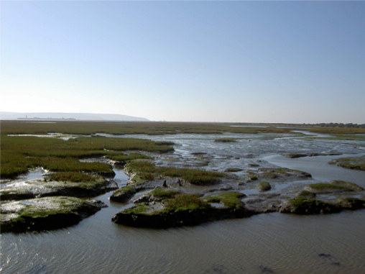
Keyhaven Marsh -
A buffer against
sea floods

Moya Grove
Sept 2021

