A week in the life of Dee Haas, CPRE Hampshire Chair

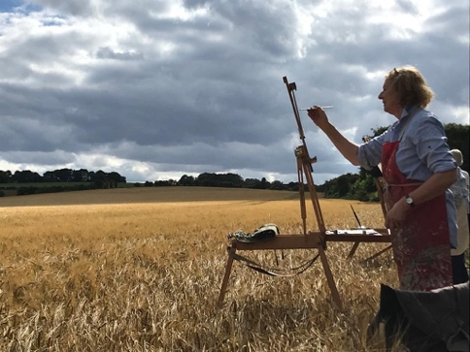
Dee also enjoys art and is seen here painting a landscape under threat near Cliddesden in North Hampshire

CPRE Hampshire keeps me very busy and it is a varied menu of activities! A typical week would look like last week:

Monday - catching up with emails of various kinds, I tend to receive between 15 and 30 emails daily, from general issues generated by our National Charity (including reading the output of the ‘Rewilding Task and Finish Group’) to CPRE Hampshire management issues. So, Monday saw me having a virtual meeting with Chair of our Planning and Policy Group, Carole Oldham, to plan our first post-lockdown face to face workshop on CPRE’s Regeneration Manifesto and how we in Hampshire can align with it. The Government’s Planning White Paper is out, and we realise that half the morning will have to be dedicated to that. We in Hampshire need to bring together our supporter’s views on how these changes will impact the countryside here.

Tuesday morning sees me on a Zoom call with the County Branch Forum in the morning. The subject is Renewable Energy and how CPRE can align their climate change policy with inevitable objections to solar arrays and windfarms in the countryside… In the afternoon, I have a catch-up meeting face to face with our new Membership and Volunteer Coordinator, Natalie Hargreaves. She has recently started in the job and is based at our office in Winchester.

The weather is so awful on Wednesday that we have to cancel a planned walk around a site in South Winchester to discuss protecting a green space for the enjoyment of the residents nearby. We have to be satisfied with a Teams meeting and a map! In the evening I attend a face to face meeting with ‘STaNHD’, an action group fighting a proposal for 2,500 houses on lovely countryside South of Basingstoke.

On Thursday I’m up in London for a site meeting - non CPRE work! (I also work as a landscape architect). On the way back I help to set up the barn we are borrowing for tomorrow’s workshop – it’s all social distancing so although only ten participants, we need plenty of space.

On Friday I take the tea, coffee and biscuits and Carole and I set up, ready to get stuck into a good discussion about the worrying Planning White Paper and how we in Hampshire want to respond to it as well as feeding into a ‘One CPRE’ response nationally. It is great to be meeting face to face again and after a coffee break, we concentrate on CPRE’s Regeneration Manifesto and what it means for us here in Hampshire. The outcomes are recorded on flipcharts and I type them up later in the day to circulate along with actions. Friday afternoon is a Zoom meeting with CPRE South East Regional Group, along with Caroline Dibden our Vice Chair to discuss reactions to the White Paper from our colleagues in other counties.

On Saturday we join some friends at West Green House near Hook for the first live music we’ve heard since lockdown. It is wonderful to be outside, enjoying the atmosphere of a live concert and a picnic lunch! Dee Haas, 26 August 2020

